Neovolt Modbus Setup Guide
This guide will walk you through connecting your Neovolt inverter to your network using a WiFi RS485 adapter.
What You'll Need
- EW11A WiFi RS485 Adapter (whole kit)
  - Available from various sources, but I use this one : AliExpress
- Ethernet cable (you'll be cutting this, so use a spare)
- Small screwdriver for terminal blocks and inverter cover

Step 1: Prepare the Ethernet Cable
- Cut your ethernet cable in half
- Strip back the wires on one cut end to expose the individual conductors
- Check you have the correct half - you want the piece with the RJ45 plug intact (reference image)

Step 2: Wire the Adapter Cable
The supplied green terminal block has labels printed above it:
A + - B
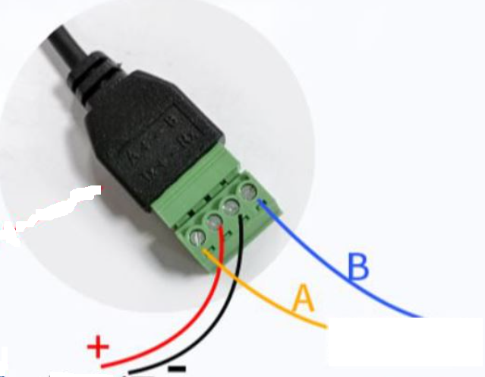
Connect your stripped ethernet wires to the terminal block as follows:
Terminal | Wire Color
A | Blue/white striped
+ | Orange/white striped
- | Green/white striped
B | Blue (solid)
Screw each wire firmly into its terminal.

Step 3: Connect to the Neovolt Inverter
- Remove the 4 screws holding the cover plate on your Neovolt inverter, being careful not to dislodge other existing wires going through other glands.
- Locate the RJ485 port (2nd port from the bottom)
- Route the cable through the bottom gland
- Plug the supplied black ethernet cable into the EW11A box
- Connect the other end to the RJ485 port on the inverter
- The EW11A ethernet port LED should begin flickering

Step 4: Initial WiFi Configuration
- Wait a few moments for the device to boot up
- Look for a new WiFi network starting with "EW11..."
- Connect to this network (no password required initially)
- Accept any connection prompts that appear

Step 5: Configure WiFi Settings
- Open a web browser and navigate to: 10.10.100.254
- Login with:
  - Username: admin
  - Password: admin
- Go to System Setting
- Scroll down to WiFi Settings
- Set WiFi mode to STA
- Click the Scan button
- Select your home WiFi network from the list
- Enter your WiFi password
- Scroll to the bottom and click Submit

Step 6: Reconnect the Adapter
- Unplug the black ethernet cable from the EW11A
- Wait a moment
- Plug it back in
The device should now appear on your home network (named "EW11..." or similar).
Recommended: Assign a static IP address to the EW11A in your router's DHCP settings to prevent the IP from changing. Also suggest preventing the EW11A from connected to internet (lock it in parental control settings etc), to be sure your data isn’t accessed externally to your home network.

Step 7: Configure Serial Port Settings
- Find the EW11A's IP address on your network
- Enter this IP address in your browser
- Navigate to Serial port settings and configure:
  - Baud rate: 9600
  - Data Bit: 8
  - Stop Bit: 1
  - Parity: None
  - Flow Control: Disable
  - Protocol: Modbus
- Click Submit to save

Step 8: Configure Communication Settings
In the same interface, configure the Communication Settings:
- Protocol: TCP Server
- Local Port: 502
Click Submit to save.

Ready for Home Assistant
Your Neovolt inverter is now connected to your network via Modbus TCP! You'll need:
- Host IP: Your EW11A's IP address (e.g., 192.168.1.x)
- Port: 502
- Slave ID: 85
You're now ready to integrate this with Home Assistant https://github.com/pvandenh/NeovoltBattery_ModbusPlugin

